**­­Things to learn**

* Find out how haast makes its money!
* 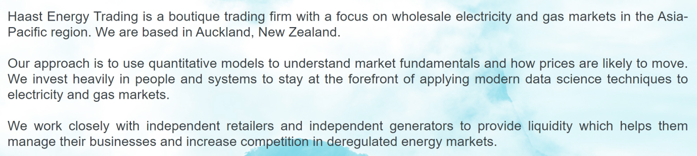
* drivers of commodity price - can I find some historic data to work with?

**From job description**

* exciting industry of finance and derivatives trading – can I show I’m interested? E.g. economics explained. Plus building my own retirement planner and spend tracker dashboards, can I talk to these and maybe have a demo of the retirement planner? **Also ensure spend tracker is up to date in case they ask**
* must be results oriented, not a perfectionist. 8020 is the motto. Pragmatic and commercially minded – from PhD (pumped out the work) and from current job (short turnarounds/must come in under budget)
* forecast commodity price and their drivers as the main responsibility – so need explanatory and predictive (timeseries) modelling
* dashboards
* communicate insights
* demonstrable experience building statistical and data science models
* exceptional academic record
* expertise in R with a bit of SQL thrown in
* highly motivated and autonomous:
* can work alone from home, e.g. PhD and work
* can work without supervision, e.g. PhD and work
* Will they be miserable working alone? No, PhD. Although collaboration is important for me it doesn’t have to be constant or ever in person
* discussions or fixes might be required after hours. Can I demonstrate this anywhere? Or maybe just say “highly flexible”

**other stuff to mention**

deep learning? Big data? Cloud computing and model deployment? Project management?